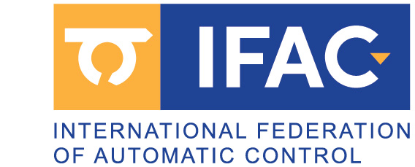

BECOME AN IFAC AFFILIATE!

If you are interested in Control Engineering you should become an

IFAC AFFILIATE

This gives you the following benefits

- Free subscription to the IFAC Newsletter
- This bimonthly Newsletter contains information about IFAC’s technical activities and forthcoming IFAC events all over the world.

- Automatic inclusion of your name in our mailing lists for forthcoming events in your areas of interest
- IFAC organizes about 40 technical meetings all over the world each year

- Subscription to the IFAC Journals at a reduced Affiliate rate
- Subscription forms can be obtained by marking the appropriate box on the on-line Affiliate Registration Form, or by writing to the IFAC Secretariat directly.

- Contribution and participation in IFAC’s technical work
- IFAC at present has more than 40 technical bodies covering all aspects of Automatic Control Engineering

How to join?

Make an on-line registration directly from the
IFAC website:

http://www.ifac-control.org/

http://www.ifac-control.org/about/ifac-affiliate-registration

